Mapping the Positive Deviance MRSA Prevention Networks at the VA Pittsburgh Healthcare System
Acute Care and Long-term Care Facilities

DRAFT 8/10/07

In July 2005, VA Pittsburgh Healthcare System (VAPHS) initiated a Positive Deviance (PD) approach to MRSA prevention with support from Jerry and Monique Sternin of the Positive Deviance Initiative at Tufts University. Subsequently, VAPHS became a Beta Site in the Plexus Institute PD MRSA Prevention Partnership funded by The Robert Wood Johnson Foundation. In order to support VAPHS’s efforts to understand the impact of the PD process on its MRSA prevention efforts and to foster learning about the PD approach to MRSA efforts among the other Beta Site hospitals, Plexus retained June Holley, an expert on social networks, to conduct a social network analysis of the VAPHS’ PD initiative.

In the spring of 2007, four units—two in the Acute Care facility at University Drive and two at the H J Heinz Long-term Care Facility—were surveyed to identify networks of individuals involved in MRSA reduction efforts.

Networks that have a large core of overlapping clusters of individuals from different units or organizations and a sizable periphery of loose connections that bring in new ideas and resource are particularly effective in generating and diffusing innovations. We call such networks Smart Networks. An example of a Smart Network is shown below. The strategy of the Positive Deviance MRSA prevention project is to encourage staff to work together across roles and units to come up with innovative actions that lower MRSA transmission. We want to see whether the Positive Deviance strategy moves the hospital system closer to a Smart Network Structure, and to see if there was a correspondence between network health (as measured by a set of social network analysis metrics) and MRSA transmission rates.
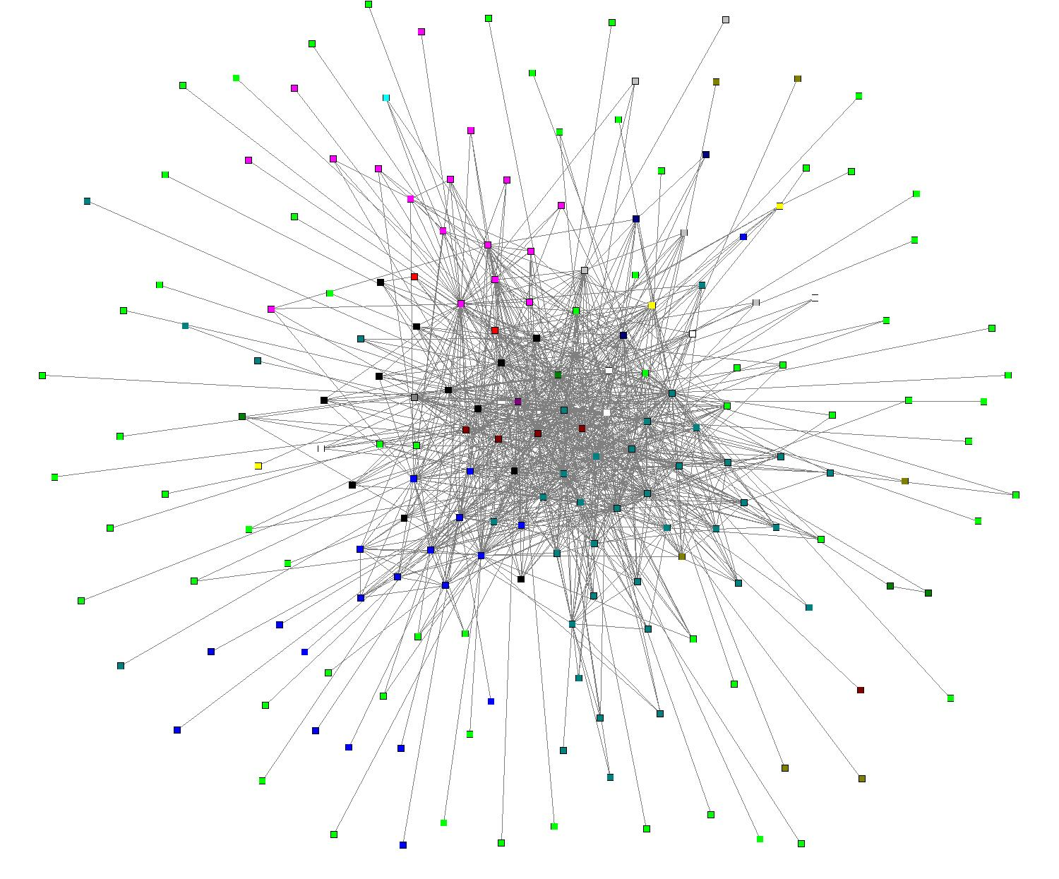
Map 1. Example of a Smart Network

The five questions asked in the survey were:

- With whom did you work on MRSA reduction efforts before July 2005?
- With whom have you worked on MRSA reduction efforts since July 2005?
- Over the past 15 months, from whom have you gotten new ideas or inspiration that helped you in your MRS reduction efforts?
- List projects and activities and people you have worked with on those projects.
- Who would you like to work with during the coming year on MRSA reduction efforts?

We labeled the networks formed from these responses
- Initial Network
- Current Network
- Innovation Network
- Project Network and
- Potential Network.

Fifty four of the unit and MRSA staff responded to the survey. The results of the survey were entered into Smart Network Analyzer Network Mapping Software and a set of network maps and network metrics generated.

The map of MRSA-reduction relation-ships before July 2005 is shown on the following page. See full legend at end of document.

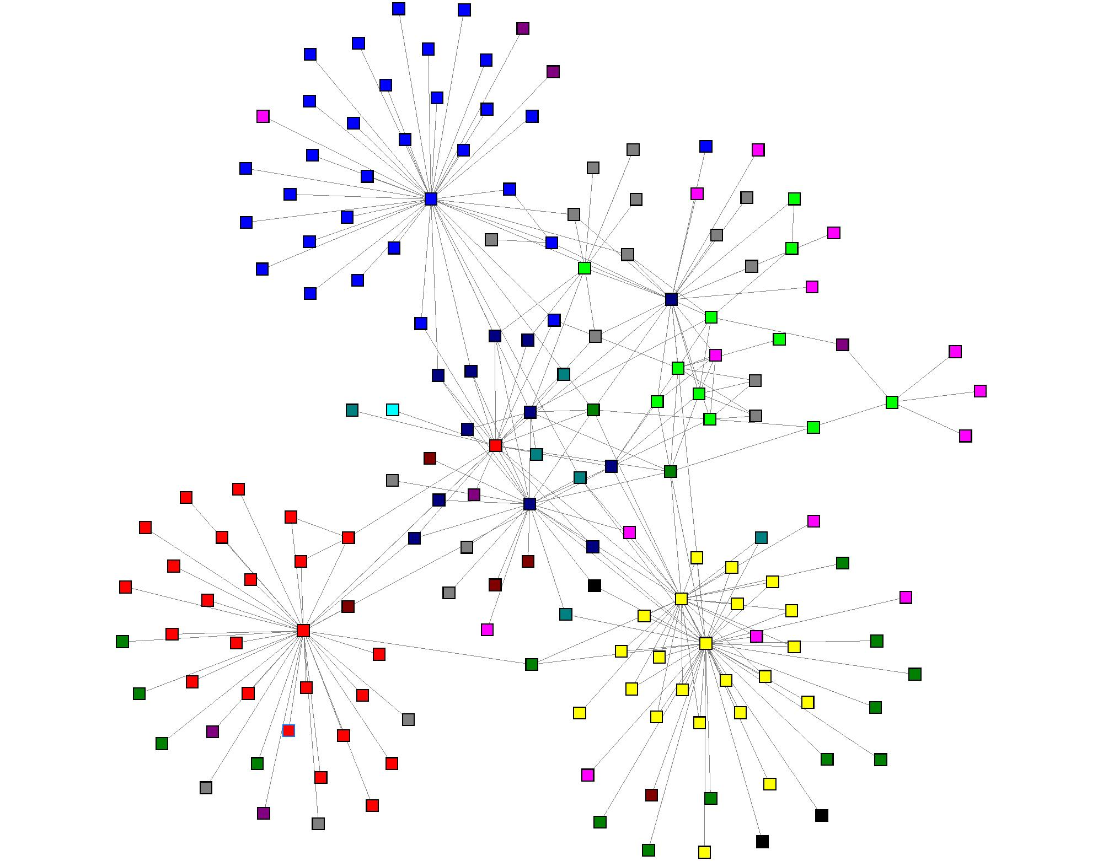

Map 2. Initial MRSA network, July 2005 (see legend on page 11)

Although the executive staff and MRSA staff (dark blue nodes in the center) worked with each other on MRSA reduction before 2005, the unit staff had less involvement in MRSA reduction at this time. Staff on the four units are colored red, green, blue and yellow. In three of the units, one or two individuals worked with a large number of others on MRSA reduction, but most individuals in the units did not check any names for this question. However, the other unit (represented by green nodes) has a quite different pattern. This unit shows no hub (a dominant node with many connections) as the other three units do. Instead, quite a few individuals answered this question, mentioning a small number of others, both other staff in the unit and others outside the unit.

Over the next two years, those involved in facilitating the Positive Deviance initiative encouraged staff to identify MRSA prevention and reduction practices that were already working and expand the numbers of individuals using that practice, as we as generate and employ new MRSA prevention practices Individuals were encouraged to self-organize to implement new practices. Not surprisingly, the processes involved in the Positive Deviance Project enabled staff to develop new relationships with others in their units and throughout VAPHS. The map of the current network is shown in Map 3 on the following page.

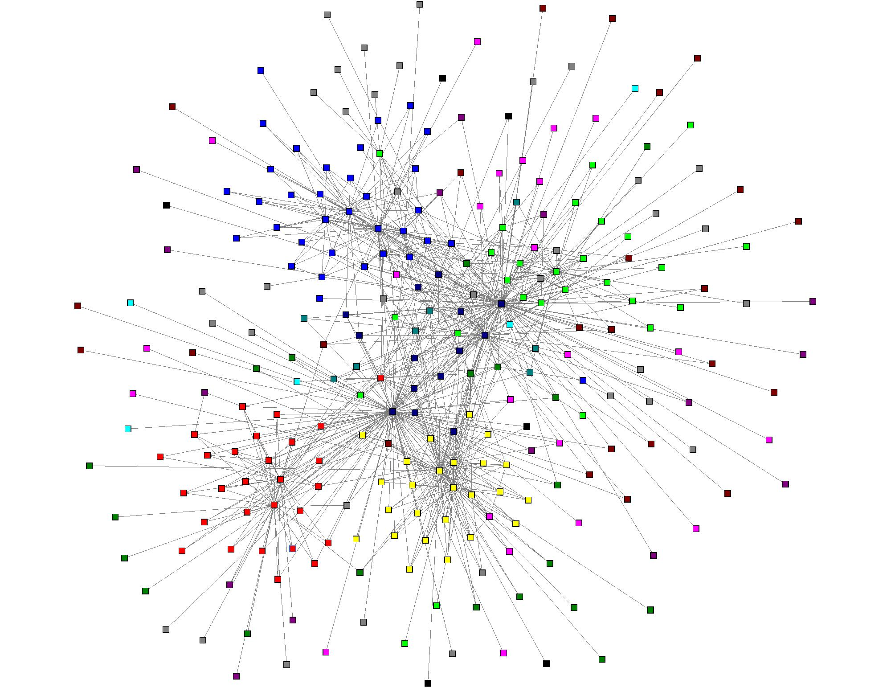

Map 3. Current Positive Deviance MRSA Prevention Network

This network has expanded dramatically and is more connected, especially within the units and between the units and executive leadership in dark blue. This network pattern indicates that many people in the hospital system are now working together to generate effective solutions to MRSA spread. Not surprisingly, this increased connectivity corresponds to a dramatic decrease in MRSA infections and transmissions: a 50% reduction in transmissions/infections in the first 18 months of the program.

Although we can see the shift in the pattern of the network from less to more connectivity, the improvement in the health of the network can also be quantitatively measured using the metrics on the following page.

Social Network Analysis Metrics

These metrics were developed by Valdis Krebs, a noted social network consultant
and researcher.

Awareness: How likely is it that information will spread throughout the network?
Who knows what is happening in the network?

Connector: Who links people who would not otherwise be connected? How
connected are parts of the network?

Integration: What is the overall network health? Who are network leaders?

Chart 1 shows that Awareness—how likely it is that people in one part of the network know what is happening in the other units—is currently 4 times greater than before the project began. This means that information is flowing more effectiveness throughout the network than it did before the project began. The Connector score—which measures overall connectivity—is 26 times greater. This means that staff are communicating and working with many more other staff than they had previously. Integration—a measure of overall network health—is 9 times greater. The green and blue units have started to form a core and the network now has a substantial periphery, which means the network is moving closer to fitting the Smart Network Structure.

Chart 1. Comparison of Initial and Current Networks

PGHVA METRICS
INITIAL |  |  | CURRENT |  | INCREASE
Q1  July 2005 |  |  | (Q1-Q4)  March 2007 |  | Since Initial
Awareness
Mean: | 3.78 |  | Mean: | 16.59 | 4 times
Connector
Mean: | 11.03 |  | Mean: | 290.68 | 26 times
Integration
Mean: | 17.69 |  | Mean: | 163.5 | 9 times

However it is important to note that there are three major hubs in the center of the network—these important leaders are Dr. Jon Lloyd, who helped initiate the PD MRSA, and the two MRSA coordinators, Candace Cunningham who works with the units at University Drive and Cheryl Creen who works at the H J Heinz facility. These three have been critical in assisting the units in their MRSA prevention efforts and in connecting them to others who can help them. However, the network is very dependent on them: when we remove just these three individuals from the network, the network becomes almost five times less connected and integrated.

The network is currently at the start of Stage 3 in the development of a Smart Network where it is critical for the network hubs to do more linking of individuals among the units so that they can communicate and collaborate directly. This way, the hubs will not become overwhelmed or become bottlenecks and the network becomes more self-organizing. Not placing so much reliance on these network hubs helps the network become more resilient.

The next step is to look at the units and how they differ in their network configurations. In Map 4, when we remove all nodes but unit staff (pink are environmental management services and dark purple are ward clerks), we see that individuals in the green unit are fairly evenly connected, while individuals in the red unit are connected primarily through two hubs. There is little connection between the units.

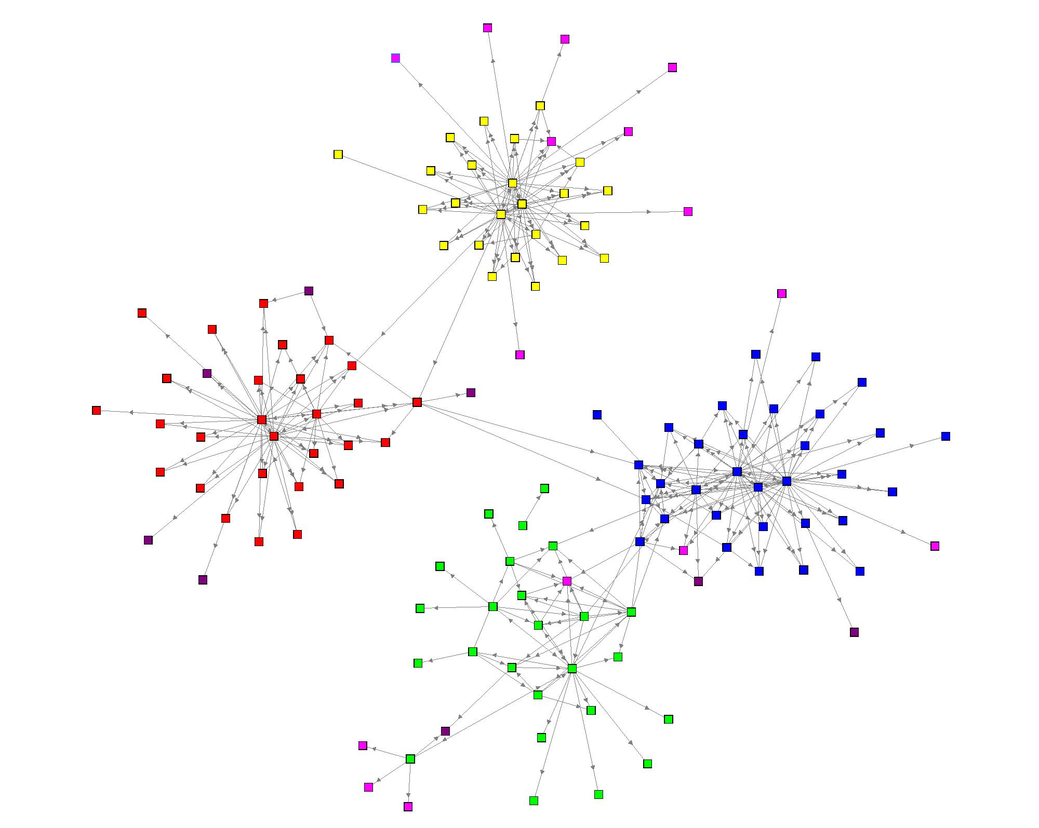

Map 4. Networks among and within units

When we look at the chart on the following page, we see that the green unit is the most strongly connected within the unit and has the highest network health or integration score. The green unit also has the lowest transmission rates. The red unit, which has the lowest connection and integration scores, also has the highest transmission rate. Though we need to do analysis of more units to really understand the connection between network scores and MRSA rates, it appears that units that are more evenly connected within the unit and well connected to resources and expertise outside the unit are more likely to have better MRSA rates.

Chart 2. Unit Network and MRSA metrics
Unit Metrics
Unit 1 |  |  | Unit 2 |  | Unit 3 |  | Unit 4
Connector
37.93 |  |  | 5.95 |  | 2.3 |  | 11.25
Integration
36.13 |  |  | 18.82 |  | 11 |  | 23.19
MRSA Transmission Rate/1000 BDOC 6 months
0.733 |  |  | 0.765 |  | 3.17 |  | 2.65*
LOWEST |  |  |  |  | HIGHEST
*This rate is higher due to a large transmission rate in January. The rate for the most recent five months is .93 which more closely reflects the network metrics.

Another way that the units differ is in their approach to MRSA reduction projects. The map below shows the names that survey participants provided of individuals with whom they had participated in MRSA reduction projects.

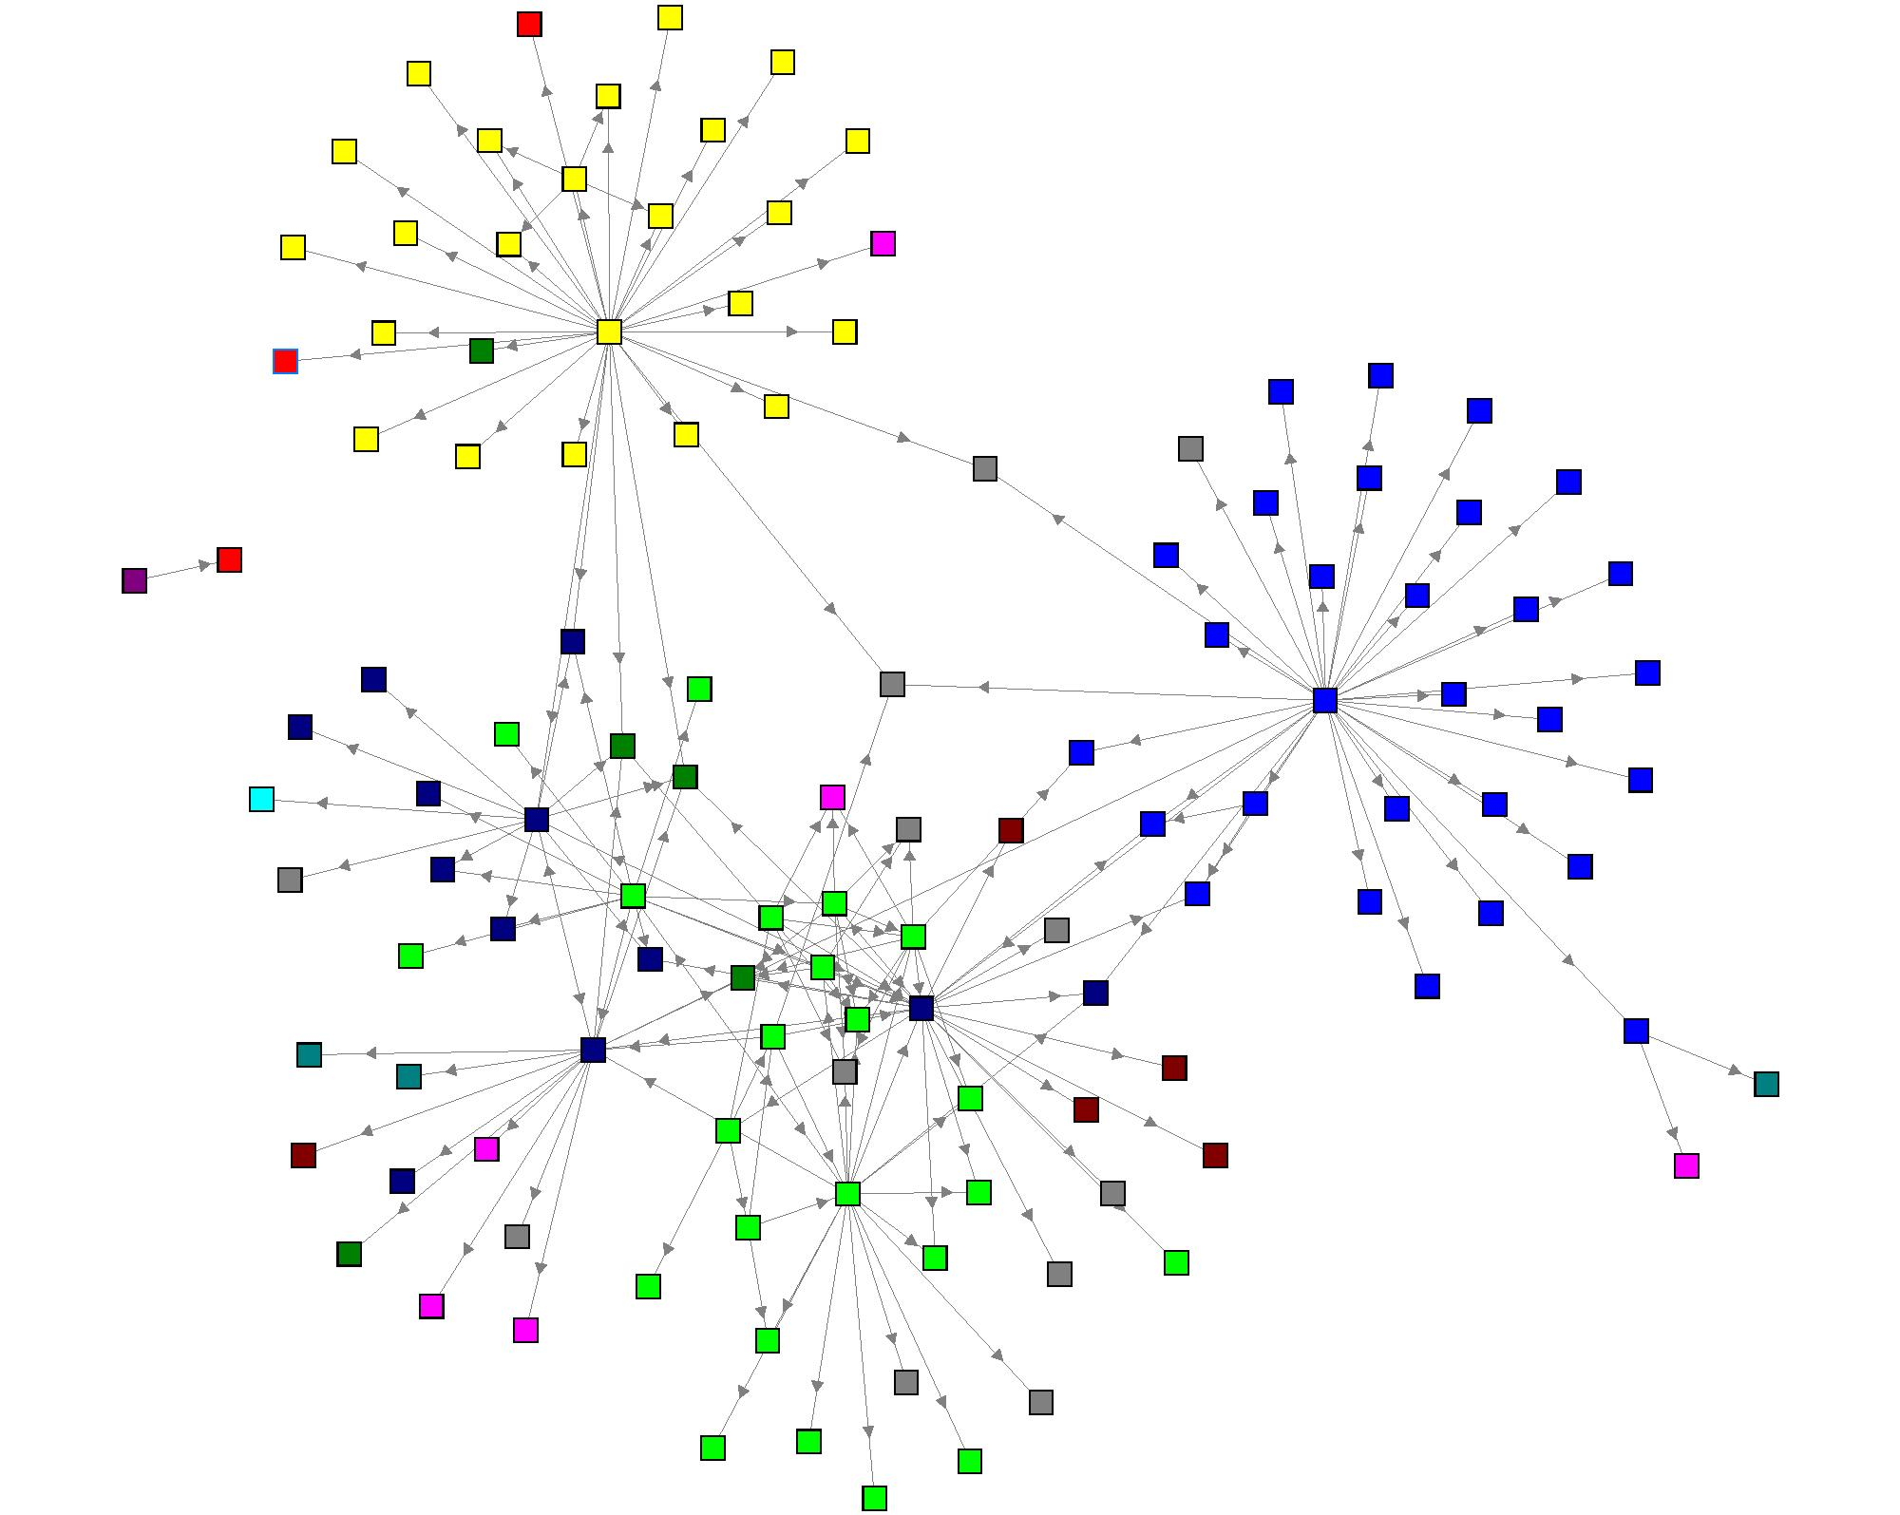
Map 5. Project Networks

No one in the red unit offered any names in answer to the question. In the yellow and blue units, most of the project generation reported was by one individual. However, for both the MRSA leadership (dark blue nodes) and the green unit, many individuals answered the question with a combination of others within their unit and people in a range of roles from environmental services to staff in the Infectious Disease unit (dark green nodes).

This configuration provides more information helping to explain why the green unit has such low MRSA rates: Many individuals in the unit answered this question, showing that a significant proportion of individuals on this unit are actively engaged in MRSA prevention projects. The staff in this unit appears to come up with ideas for improvement, pull together those within their unit and other resources people, and implement their ideas in ways that bring about a drop in MRSA transmissions.

Another way that the units differ is in their approach to innovation, in this case new approaches to MRSA reduction. The map below shows individuals’ response to the question, “From whom have you gotten new ideas or inspiration that increased the success of your MRSA reduction efforts?”

The yellow and red units listed only a small number of names of innovators, and interestingly, the red unit only named others within their unit. The green unit staff, in contrast, named innovators both within their unit (including quite a few of the housekeeping staff and ward clerks) and within the MRSA and executive staff. Blue staff responded with many names, most of them within their unit.

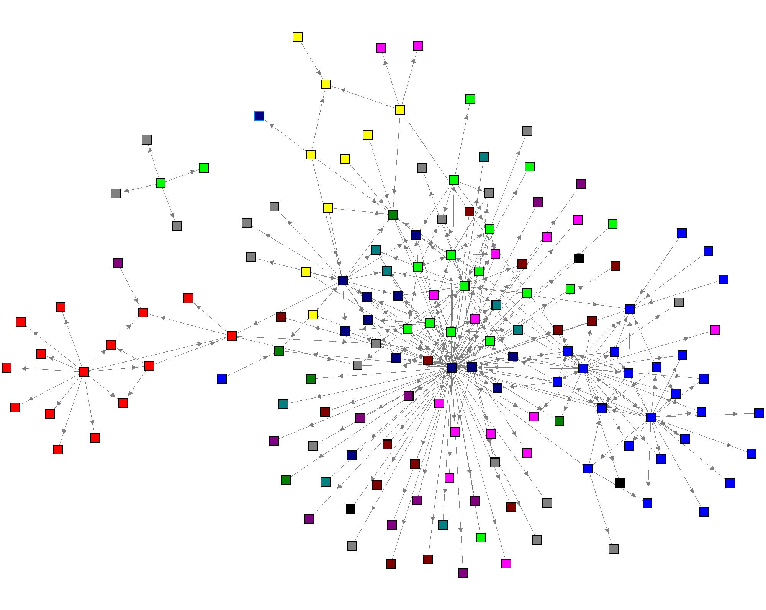
Map 6. Innovation Network

Again, when we remove the non unit staff nodes below, we see that only the green unit is getting innovation from other units. This is an opportunity for the system: if several people in each unit were better connected to individuals in other units, then more information about innovative successes (and insightful failures) discovered in each unit would flow more easily from unit to unit—thus giving each unit a much larger pool of experience and innovation to choose from in their strategies.
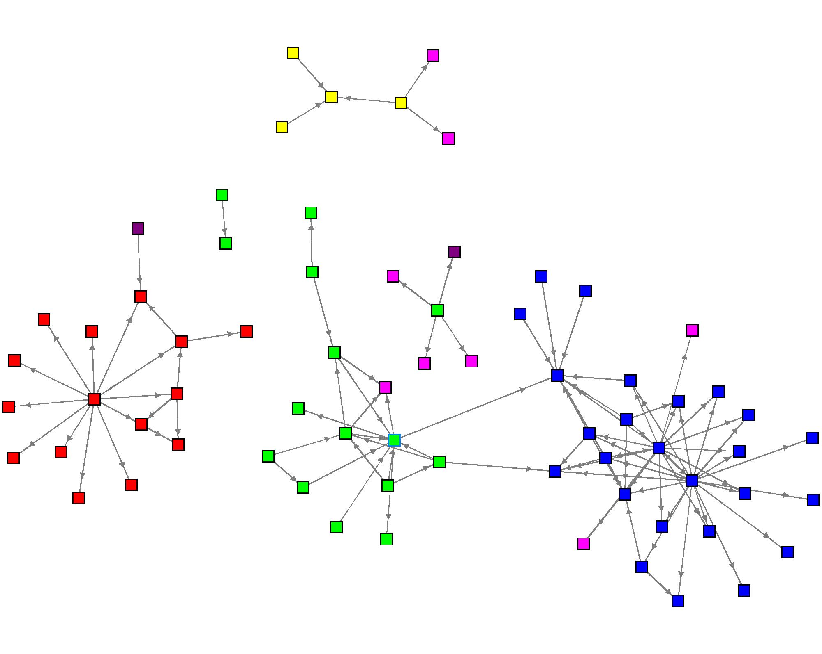

Map 6. Innovation Diffusion Among Units

If we ask people who they would like to work with on MRSA reduction projects, and add the results to the existing network, we end up with the map below and a significant improvement in the network metrics.

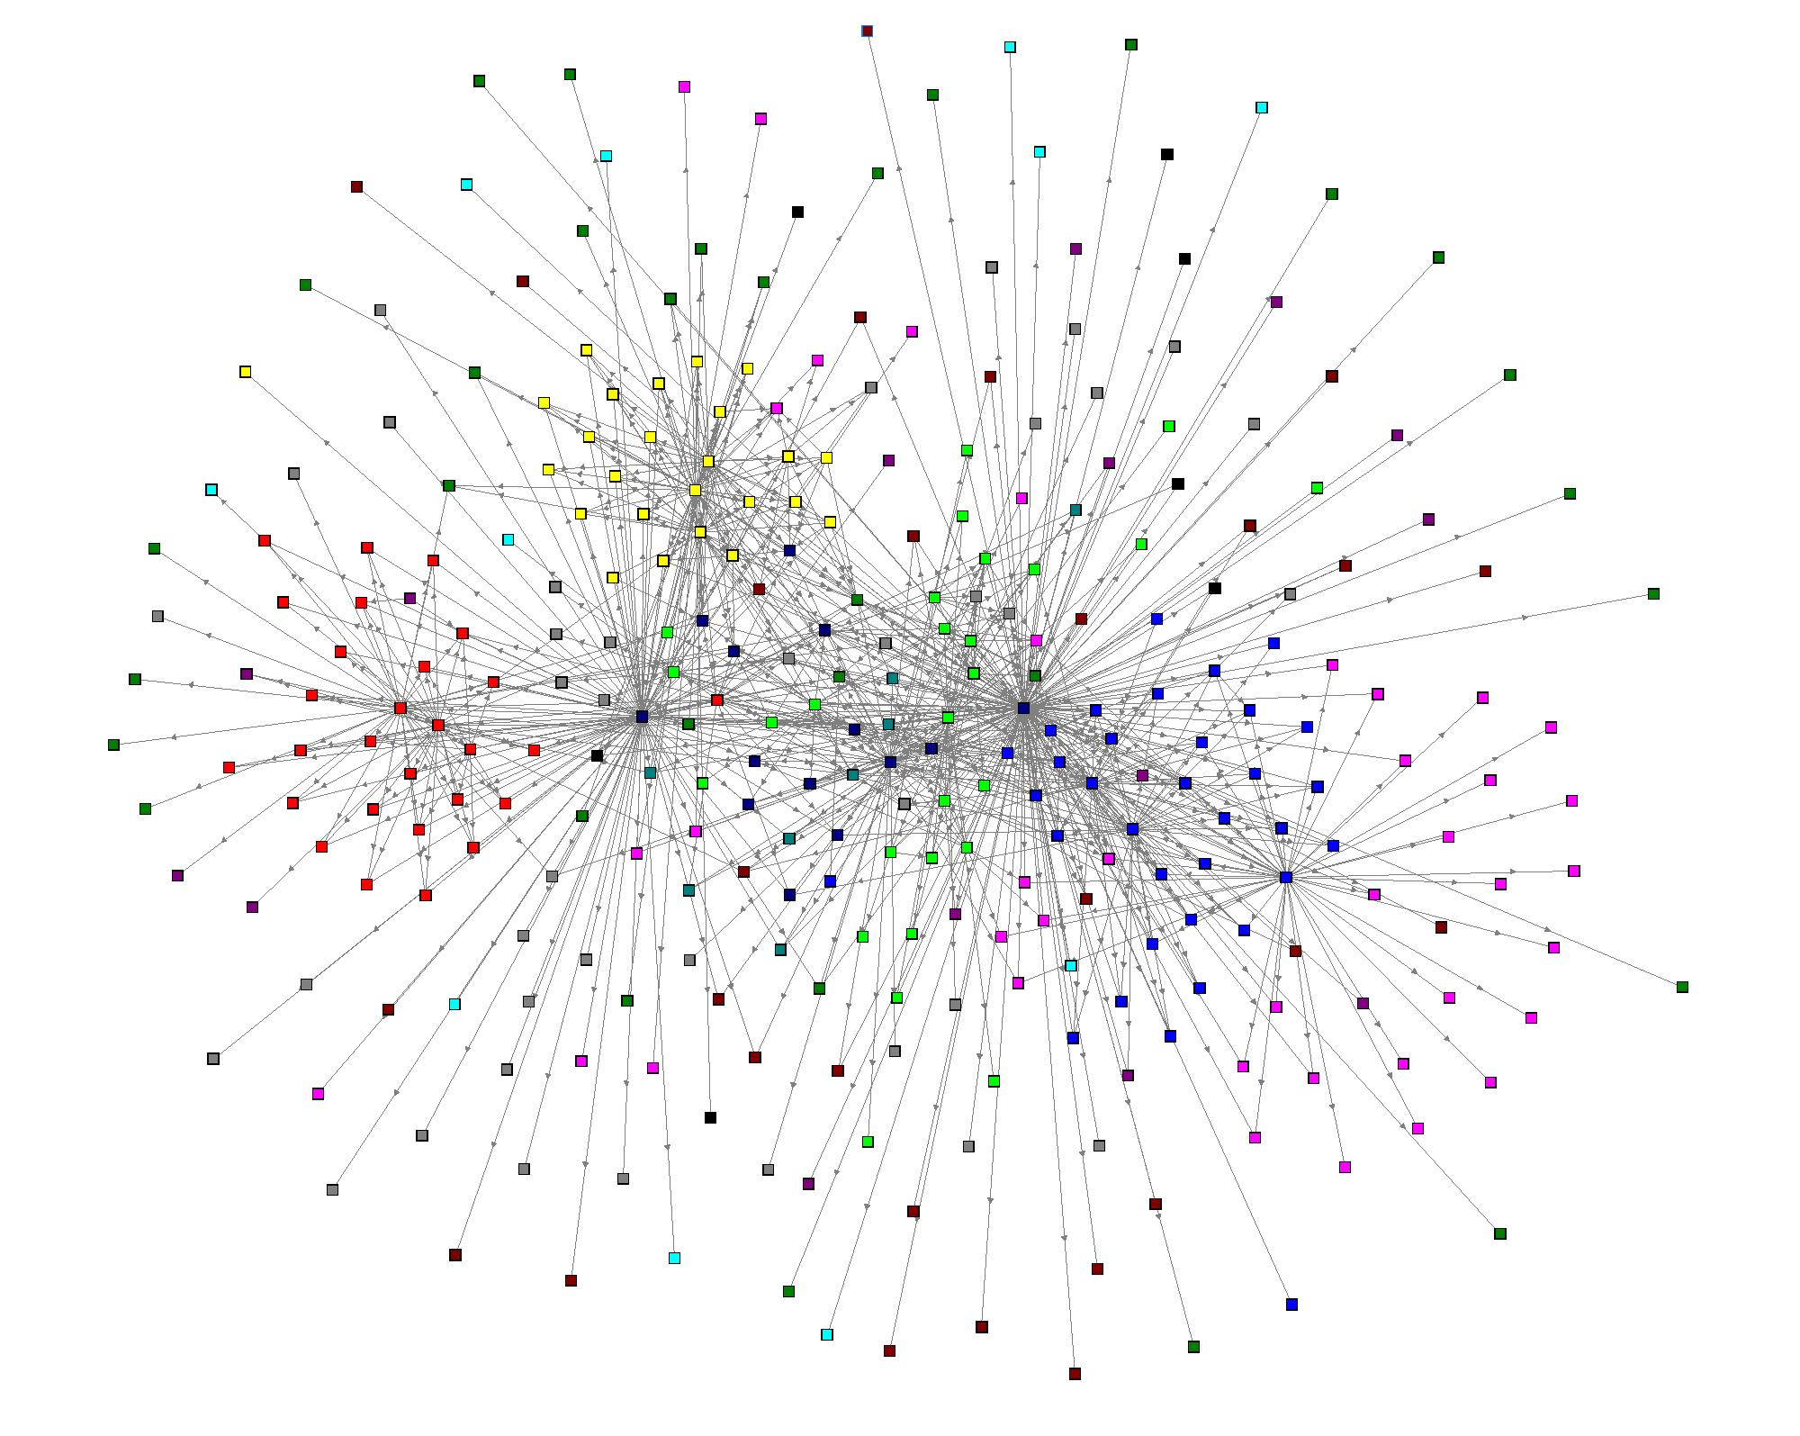
Map 7. Potential Network

The metrics in the chart on the following page show that if leadership were able to support individuals, enabling them to work with those they wanted to work with on MRSA reduction projects, the network would become more effectively connected—leading to better future communication and self-organization. The Integration or Network Health score for the Potential Network is 11 times the score of the Initial Network.

Chart 3. Comparison of actual network to potential network

Potential Improvement
 | INITIAL | CURRENT | POTENTIAL | SIMULATION
 | Q1 | Q1-Q4 | Q1-Q5
Awareness
Mean: | 3.78 | 16.59 | 20.13 | 23.53
Connector
Mean: | 11.03 | 290.68 | 356.83 | 407.4
Integration
Mean: | 17.69 | 163.5 | 186.07 | 301.62

How can these maps and metrics be used to enhance an organization’s networks and lead to desired outcomes? We use a process called Network Weaving that includes some or all of the individuals who took the survey in an analysis the maps and the metrics and then in the development of strategies for improving the network. We will be engaging in such a process with VAPHS staff next month.

The process operates on several levels. First, having a visual map of their workplace encourages people to be more relational and collaborative in their work. At the same time, the whole network metrics provide a more sophisticated understanding of the network, and guidance in qualities of the network that can be improved. And finally, the individual metrics help identify different types of emerging leaders who can be supported to take initiative in mobilizing collaborative projects. For example, one survey taker—a nurse—listed the names of ten environmental services staff s/he would like to work with on MRSA innovations. If the organization can support her and others in this effort, MRSA reduction is likely to continue to improve.

In addition, the network mapping software enables the units and MRSA staff to identify potential scenarios for enhancing the networks. For example, if the people in each of the units with the highest Connector scores could get to know each other, increase their communication about their MRSA efforts and even begin working on joint MRSA prevention project, the network metrics would increase even more. A simulation was done connecting a small number of people in each unit with others in other units. As shown in the far right column in the chart above, the Integration or network health score almost doubles from the present situation as a result.

Conclusion

This mapping project represents the first attempt to use network mapping as part of the Positive Deviance strategy to prevent MRSA transmission and infections in hospitals. The mapping process reveals that network health, as measured by a set of social network analysis metrics, corresponds to low MRSA transmission rates. The analysis process also shows steps that could be taken—using a combination of staff’s interest in working with others and some additional strategic linkages to connect individuals across units—that would be likely to further lower MRSA rates throughout the hospital system.

For further information contact:

June Holley Curt Lindberg
Network Weaver Plexus Institute
740-591-4705 609-208-2930
june@networkweaving.com curt@plexusinstitute.org

Appendix 1. Legend

□ Unit 1
□ Unit 2
□ Unit 3
□ Other Medicine
□MRSA/Executive Staff
□ Laboratory
□ CommCenter
□ PTOTKT
□ EnvManageSrvc
□ Unit 4
□ Vet/Family/Volunteer
□ Other

For more information about Smart Networks see www.networkweaving.com/june,html
Map derived from responses to Question 1, see page 1 for exact wording.
Map derived from responses to Questions 1 through 4, see page 1 for exact wording.
For a paper on Stages of Network Development see www.orgnet.com/

