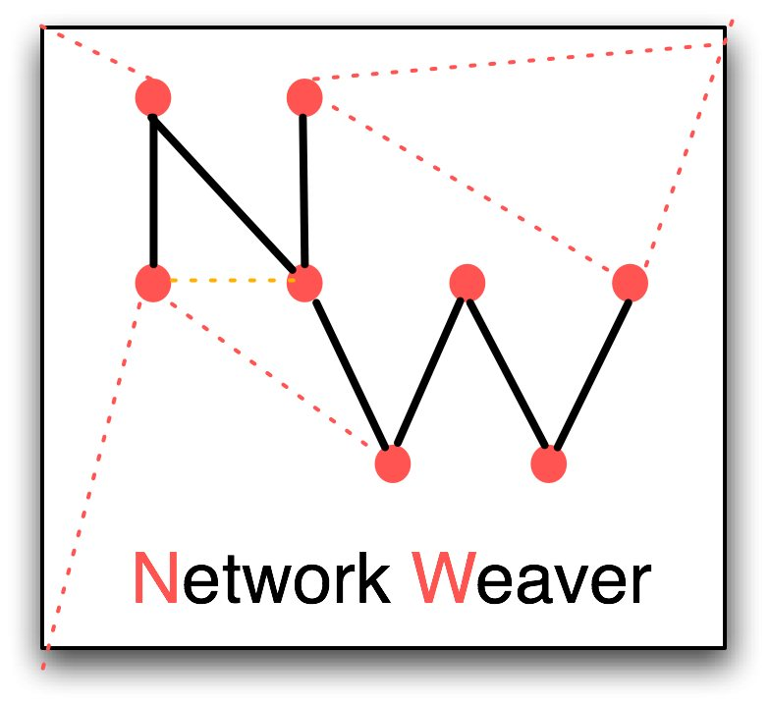

June Holley
Network Weaver
8 Lincoln Street● Athens, OH 45701 ● USA
740-591-4705 ● june@networkweaving.com ● www.networkweaver.com
www.networkweaving.com (blog)

Named as one of the top ten network experts in the world by Stan Garfield of Hewlett Packard

EXPERIENCE

1990-present Consultant

Major specialties:
      - Network mapping and analysis
      - Network building training
      - Communities of practice for network weavers
      - Building skills in using the social web to support networks

Examples of network mapping projects used for economic transformation

- Network map generation and network effectiveness training for U.S. Department of Labor Regional Innovation Grant Projects

  - Newton Iowa: generated survey of 175 individuals (economic development, workforce and education, and government and agency staff ) in 8 counties to identify collaboration and innovation networks for revitalization and emerging business clusters

  - Siouxland Iowa with Ken Poole and Center for Regional Economic Competitiveness: generated survey of 175 individuals in 7 counties as part of strategic plan for linking workforce development and area businesses

  - Southwest Oklahoma Impact Coalition: with Corporation for Skilled Workforce surveyed 233 individuals in 18 counties to identify potential business clusters

- Newfoundland, Canada: generated network survey of 150 individuals to assist in the development of a resource-based tourism effort among 4 sub-regions where few people had worked together previously
- Heart of Wisconsin workforce/business cluster mapping and identification of 10 business clusters; development of strategic plans for each cluster
- Innovation Learning Network of 10 large hospital systems – evaluating network development over 2 year period which was used to strengthen the innovation and research network
- United Nations network mapping projects to identify and support regional leadership in East Africa, West Africa & Caribbean
- Annie E. Casey Foundation network mapping projects for Making Connections project in San Antonio and Center for Working Families in Atlanta mapping urban neighborhood networks

Examples of strategic network building projects
- Network Weaver Community of Practice for 75 grantees of 8 foundations, lead by the Packard Foundation – all virtual
- Blue Cross Blue Shield Healthy Eating Minnesota 6 month training in network building for 8 grantee networks
- Woman Donors’ Network, network analysis and training
- Barr Foundation network building training for after-school projects in Boston
- Innovation Learning Cluster of large hospital systems: network mapping & network weaving training

Examples of social web training
      - Created social media and networks weekly sandbox for national leaders
      - Developed training to incorporate use of social media into strategic network building, used by 3 projects

  - President/ CEO and founder, Appalachian Center for Economic Networks (ACEnet), Athens, Ohio.

Responsible for general oversight, research, outreach, funding, and development of new programs to support regional entrepreneurship networks

Raised $5 million for 3 incubator facilities, $3 million for loan fund.

Designed youth entrepreneurship program, food cluster initiative, national cluster-focused learning cluster project, Tracking That Makes A Difference™, entrepreneurship-led workforce strategies, and regional flavor mega-cluster strategies.

Founder Central Appalachian Network.

Co-authored more than 30 research papers and articles on community economic development. Research and policy on entrepreneurship, rural development, regional entrepreneurship networks, clusters and innovation.

1997 Featured in The Front Line in the Wall Street Journal on October 24, 1997

1994 Led a study tour with staff of Central Appalachian community groups, government agencies, foundations, and policy institutes to better understand the flexible networks of Northern Italy and Denmark.

1981-1985 Sociology Instructor, Ohio University, Athens, Ohio.

1975-1979 Social Science Instructor, West Virginia Northern Community College, New Martinsville, West Virginia.

1979-1981 Founder and partner, SOLutions, Reader, West Virginia, a solar products business

1977-1979 Coordinator, Wetzel County Vocational Counseling Program, New Martinsville, West Virginia.

1975-1977 Coordinator, Wetzel County Senior Citizen Program, New Martinsville, West Virginia.

EDUCATION

2007 Week-long training and certificate in Social Network Tools and Analysis CASOS, Carnegie Mellon University

2003 Rockefeller Fellowship, University of Kentucky

1981-1983 Master of Arts in Sociology, Ohio University, Athens, Ohio (GPA: 4.0)

1977-1979 Masters level counseling program, West Virginia University, Morgantown, WV

1969-1970 Masters of Education, Temple University (summa cum laude), Philadelphia, Pennsylvania.

1969 Bachelor of Arts, Ohio Wesleyan University (magna cum laude), Delaware, Ohio.

TEACHING AND PRESENTATIONS

2009 BALLE (Business Alliance for Local Living Economies) Keynote Speaker
California Endowment Policy Networks Training
Woman Donors’ Network Web-based Training Network
Toronto Collaborative Network Mapping and Network Weaving Training for 4
large networks in health services and arts
C2er Training in Regional Networks
Heart of Wisconsin Regional Clusters

2008 Taught Applied Qualitative Analysis: Social Network Mapping in Development, graduate course at Ohio University
International Social Network Conference, workshop presenter Network Weaving
State Microenterprise Association, Cluster Strategies for State Policy Initiatives
Heart of Wisconsin Cluster Workshop, Creating Effective Networks
National Main Street Conference, Discovering Hidden Treasures in Your Community and
Assisting Entrepreneurs
Iowa Workforce Development Council, Network Weaving Training

2007 Smart Networks, 2 day workshop in Toronto, Canada for non-profits and
foundations
ILN conference Austin Texas, Smart Networks in Health Care
AEO Cluster Convening, Introduction to Regional Flavor
Harvard University Workshop for U.S. and Canadian Foundations, Networks for Foundations
State Microenterprise Organizations, Introduction to Networks, Omaha

2006 Georgia State Entrepreneurship Conference, keynote speaker
Illinois Rural Entrepreneurship Conference, keynote speaker, Regional Flavor
Baldwin Wallace College, 2-day workshop, Smart Networks & Network Weaving
I-Open Tuesdays, Positive Deviance, Networks and Regional Innovation
Plexus Institute, Smart Networks and Network Weaving

2005 National Network of Sector Practitioners, Sectoral Entrepreneurship & Workforce
Appalachian Ohio Regional Entrepreneurship Network, Entrepreneurship in
Appalachian Ohio
Barr Foundation, Network Weaving
Fairfield Iowa Entrepreneurship Conference, The ACEnet Story
Federal Reserve Bank of Memphis Conference on Entrepreneurship, Assistance
for Impact
NorTech Scenario Planning Session, Innovation
RTS Clusters Conference, Design Principles for Rural Clusters
AEO Learning Cluster Conference, Regional Flavor
University of Oregon, Making Sustainable Development Work
Association of State Microenterprise Organizations, Trends Impacting Microenterprise
Organizations

1998 Presenter with Stuart Kauffman author of At Home in the Universe at Ernst and Young Conference on Complexity and Business.

PUBLICATIONS

2011 Network Weaver Handbook, Network Weaver Press

Conservation Stakeholder network mapping, analysis and weaving with Ken Vance-Borland, Conservation Letters

2007 Entrepreneurship with a Regional Flavor in Entrepreneurship and Local Economic Development, Norman Walzer, editor (Rowman & Littlefield)

Mapping the Positive Deviance MRSA Prevention Networks at the VA Pittsburgh
Healthcare System Acute Care and Long-term Care Facilities, Plexus Institute
Monograph

Using Network Mapping Simulations to Develop Network Strategies to Lessen Transmission
of Infection, Report for the Seattle Veterans’ Administration

2006 Regional Flavor: The Creative Power of Communities, Rural Research Reports, Vol. 17,
No. 6

2005 Entrepreneurship in Appalachian Ohio: Facts and Figures (ACEnet Institute: Athens, OH)

2005 Regional Entrepreneurship Networks: A Handbook (ACEnet Institute: Athens, OH)

Strategies for Sustainable Entrepreneurship, with Central Appalachian Network (Ohio University Voinovich Center for Public Leadership: Athens, OH)

Transforming Your Regional Economy Through Uncertainty and Surprise, in Uncertainty and Surprise in Complex Systems: Questions on Working with the Unexpected
Reuben McDaniel and Dean Driebe, Eds. (Springer-Verlag: Berlin and Heidelberg)

2004 Building Sustainable Communities Through Network Building, with Valdis Krebs, Non-Profit Quarterly, Spring 2004, Volume 11, Issue 1.

2001 Accessing Lucrative Markets, published by the Ms. Foundation.

2000 Collaborative Cause Marketing for Specialty Food Businesses, Research report for EDA, published by ACEnet Institute.

1998 Telecommunications Policy in the Public Interest and Designing Telecommunications Infrastructure to Revitalize Regional Economies, Community Media Review, Volume 21, Number 2

AFFILIATIONS AND VOLUNTEER ACTIVITY

2008-present Lead coordinator, Town Hall Planning Group, Athens, OH

2008-present Volunteer executive coach for young women leaders

2001-2009 Board, Plexus Institute of Complexity

2003-present Center for Rural Entrepreneurship Advisory Board

2004-2007 Policy Innovation Network Advisory Group on entrepreneurship and workforce

2000-2004 Board, Center for Labor and Community Research.

1993-2004 Board, North Central Regional Center for Rural Development.

1994-1997 President of the Ohio Community Development Corporation Association.

1991 Inducted into the Ohio Women’s Hall of Fame, Columbus, Ohio.

